AC-AC Conversion Methods

Abstract
The three common ways for AC-AC conversions are introduced in this document, they are:
- Cycloconverters
  - Blocking mode – basic operations
  - Circulating Current Mode
- DC-link converters
  - Topologies
  - Disadvantages of DC-link converter
- Matrix converter
This document also introduces the AC7 Matrix Converter by Yaskawa Electric. A discussion of these methods has been made in the end of this document.

1. Cycloconverters
Cycloconverters convert an AC waveform to another AC waveform of a lower frequency, synthesizing the output waveform from segments of the AC supply without an intermediate DC link. The output frequency of a three-phase cycloconverter must be less than about one-third to one-half the input frequency. This put a limit on the usage of cycloconverters as their frequency ranges are restricted.
Cycloconverters are used in high power applications driving induction and synchronous motors.
There are two modes of cycloconverters, namely the blocking mode and the circulating current mode.

1.1 Blocking mode – basic operations ^{[1]}

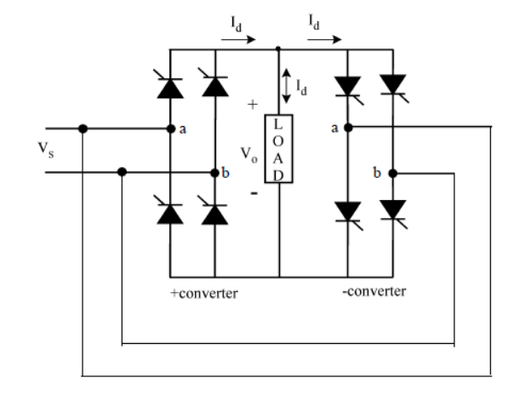
Single Phase Cycloconverter

- Two rectifiers: one positive converter and one negative converter
- When one of the converters operates the other one is disabled
- By varying firing angles, we can get more steps in outputs
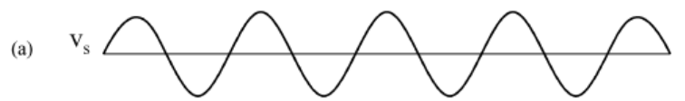
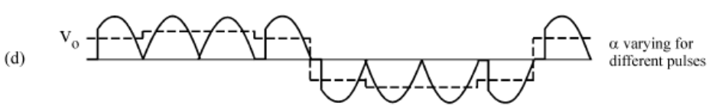

Three-to-single Half-wave Cycloconverter
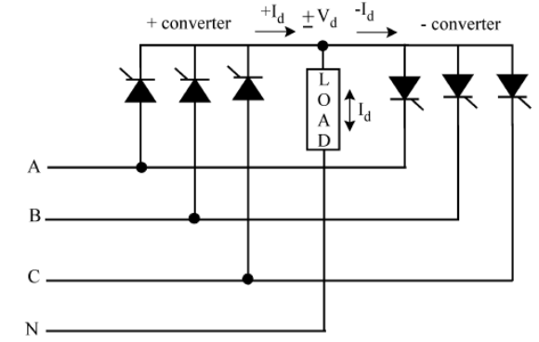

Both positive and negative converters can generate voltages at either polarity, but the positive converter can only supply positive current and the negative converter can only supply negative current.
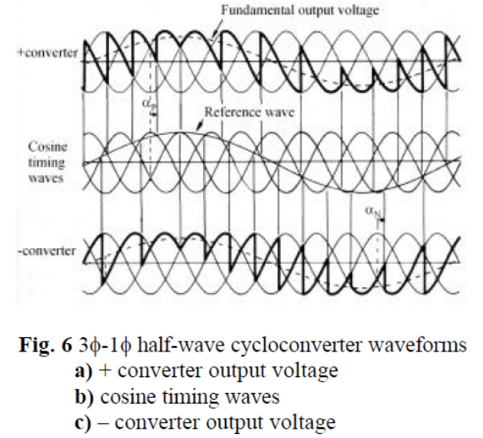

- When the polarity of the current changes, the converter previously supplying the current is disabled and the other one is enabled.
- The converters are forced to produce the same average voltage at all times. Thus
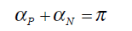

1.2 Circulating Current Mode ^{[2]}
An intergroup reactor (IGR) is connected between the positive and negative converter. Instead of blocking the converters during current reversal, if both converters are enabled, then a circulating current is produced. By contrast, the positive and negative converter in the blocking mode cycloconverter can be enabled alternatively but not concurrently.
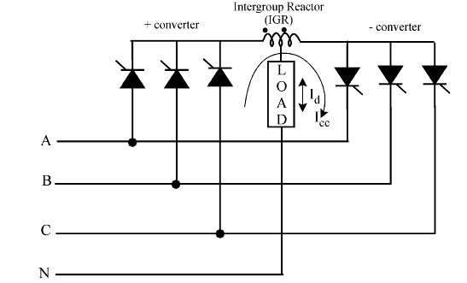

Advantages
- The output is less distorted than blocking mode
- No current reversal problems

Disadvantages
- IGRs are large in size
- More loss

2 DC- link Converter
The DC-link converter consists of a rectifier at the supply side and an inverter (usually a voltage-controlled inverter) at the load side. The DC link transmits the DC voltage to the inverter, provides ride-through capability by storing energy, and provides some isolation from the utility/line

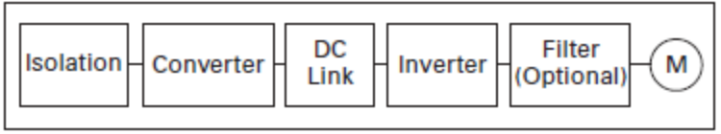

2.1 Topologies
The most common design for an indirect AC – AC converter is the use of diode bridge rectifier at the supply side, as shown in (a). However, this converter topology has high distortion in the input currents, which can cause detrimental effects to other electrical equipment using the same electrical supply.
The topology in (b) utilizes an active PWM rectifier (also known as an active front-end) replacing the diode bridge rectifier. This topology addresses the high distortion problem in (a). However, the use of active devices also increases the losses, converter volume and cost.

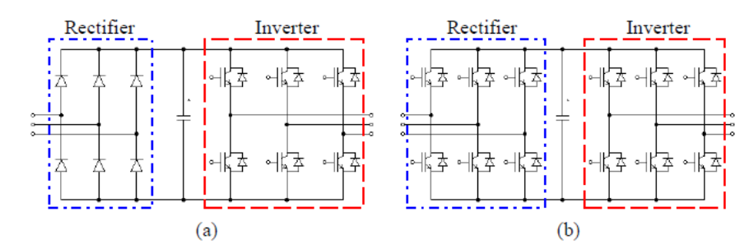

2.2 Disadvantages of DC-link converter
- Need large energy storage elements (e.g. electrolytic capacitors)
- Electrolytic capacitors have shorter lifetime, thus the overall lifetime is short
- Electrolytic capacitors bulky and unreliable at extreme temperatures
- Less efficient than cycloconverters

3 Matrix Converters

3.1 Fundamentals of Matrix Converter

Pros and Cons
+ Provides sinusoidal input and output waveforms with minimal higher order harmonics and no subharmonics
+ Bi-directional energy flow capability
+ Minimal energy storage requirements (no capacitors, inductors)
+ Input power factor can be fully controlled.
- Output voltage <= 87 % input voltage
- Requires more semiconductor devices
- Sensitive to the disturbances of the input voltage system

Topology
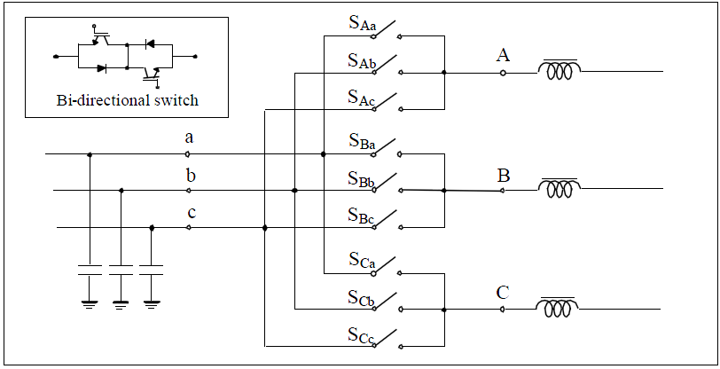

The matrix converter consists of 9 bi-directional switches (18 transistors) that allow any output phase to be connected to any input phase. The input phases should never be short-circuited and the output currents should not be interrupted. This implies that one and only one bi-directional switch per output phase must be switched on at any instant.

Problem with Implementation
The bi-directional switch realization and commutation was a problem in 1998, but there are available bi-directional switches commercially, even packed in modules that can address the commutation issues. Here are some prototypes:
DIM400PBM17-A000: IGBT bi-directional switch module

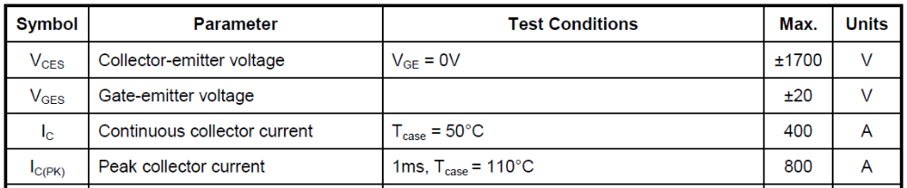

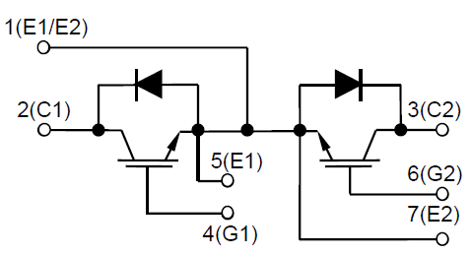

The input filter issue
The functions of an input filter are:
- To avoid significant changes of the input voltage of the converter during each PWM cycle
- To prevent unwanted harmonic currents from flowing into AC mains.

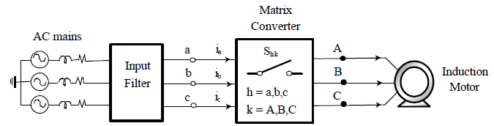

- Resonant frequency cannot be determined.
- Capacitor filters with higher values have higher displacement thus low power factor while with lower values, they cannot provide enough noise attenuation.

Protection issue
AC-AC matrices do not have free-wheeling path for the output motor currents. In 1998, there was no comprehensive protection topology that protect the converter from: over voltage and over current from input and output

3.2 AC7 Matrix Converter, Yaskawa Electric ^{[3]}
AC7 Matrix converter is the first commercialized matrix converter
The main circuit for a matrix converter consists of a compact input filter and nine bidirectional switches (Figure 1). The bidirectional switches are made up of IGBTs and diodes
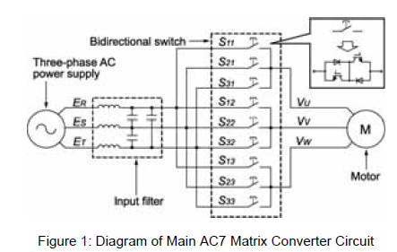

Parameters
Applicable Motor Output (W) | 5592.8 - 22371
Output current (230V) (A) | 27 - 96
Input Power Rating | 220 Vac, 50/60 Hz, 3-phase
Output frequency | 120 Hz maximum
Output Voltage | 220 * 0.93 = 204.6
Control Modes | PWM
Dimension (m) | 6.4*3.6*3.5 or 6.7*4.3*3.6
1 horsepower = 745.7 watts

PWM method
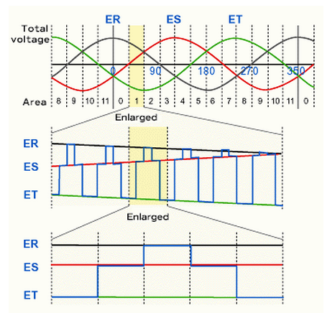

Input current harmonics
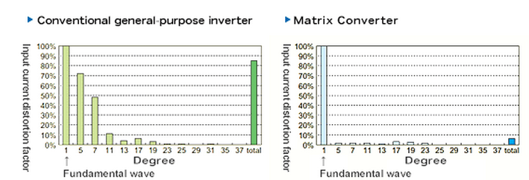

The AC7 Matrix Converter suppresses output surge voltage by 20 to 50%.

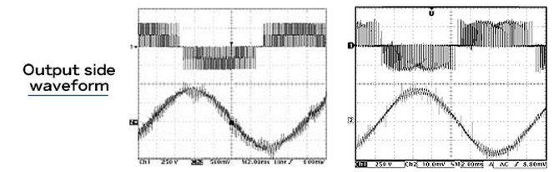

4 Discussion
Cycloconverter is overall more efficient than DC-link converter as it does not have an intermediate stage. However, it also has restrictions on the output frequency and its output frequency must be less than the input frequency. Cycloconverters are usually useful for high-power applications.
DC-link converter, on the other hand, is less efficient. As a result, it tends to lose a significant amount of power for high-power applications. Also, since the capacitor used for the link stage is usually huge, the overall size of DC-link converter is larger than a cycloconverter (blocking mode). This can be unattractive if the converter is an integrated part of a machine. However, DC-link converters are more feasible due to its low cost and high stability

The inverter model we bought was EM9-G3-011/P3.

References
[1] Burak Ozpineci, Leon M. Tolbert, CYCLOCONVERTERS, University of Tennessee-Knoxville
[2] Kevin Palani, POWER QUALITY ANALYSIS OF A THREE-PHASE CYCLOCONVERTER UNDER VARIABLE OPERATING CONDITIONS, California Polytechnic State University, 2010
[3] AC7 Matrix Converter Application Notes, Yawasaka, 2008

